Bug Report: Case-Sensitive Email Login & Error Typo
Bug ID: BUG-001 (Linked to CSC-15) Title: Login fails due to case-sensitivity on email input; "Credentials" spelt incorrectly in error toast. Severity: High (Usability Block / Professionalism) Assignee: Frontend Developer / Backend Developer
Description: The login system currently treats email addresses as case-sensitive strings. A user registered with lowercase letters cannot log in if they capitalise the first letter (a common mobile device behaviour). Additionally, the error message displayed contains a visible typo ("Credentioals").
Preconditions:
- A user is registered in the database with the email: admin@example.com
- The user is on the Login page (/login)
Steps to Reproduce:
- Navigate to the Login page.
- In the "Email" field, enter the registered email with a capitalised first letter: Admin@example.com (Note the capital 'A').
- Enter the correct password (admin123).
- Click the "Log In" button.
Expected Result:
- The system normalises the email to lowercase.
- The user is successfully authenticated and redirected to the dashboard.
Actual Result:
- Authentication Failure: The system rejects the login attempt.
- Typo in UI: An error toast appears displaying: "Authentication Error: Invalid Credentials" (Extra 'o' in credentials).
Evidence:
- See attached screenshot: LoginUsingRegisteredUserFailed.png
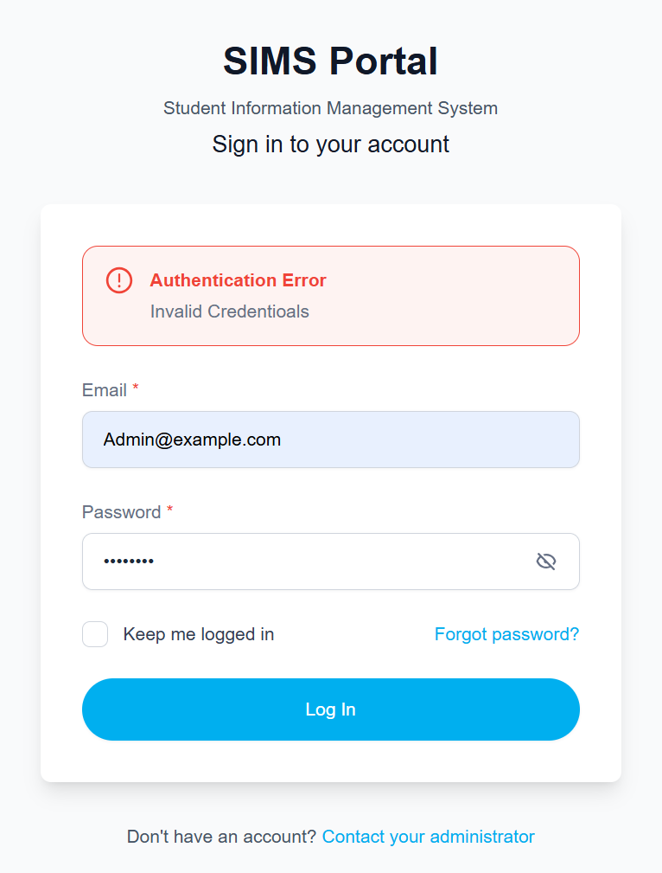
LoginUsingRegisteredUserFailed.png

